**Puppet**

Puppet is a configuration management tool.

It provides the ability to define which software and configuration a system requires and then maintain a specified state after an initial setup.

**Node**

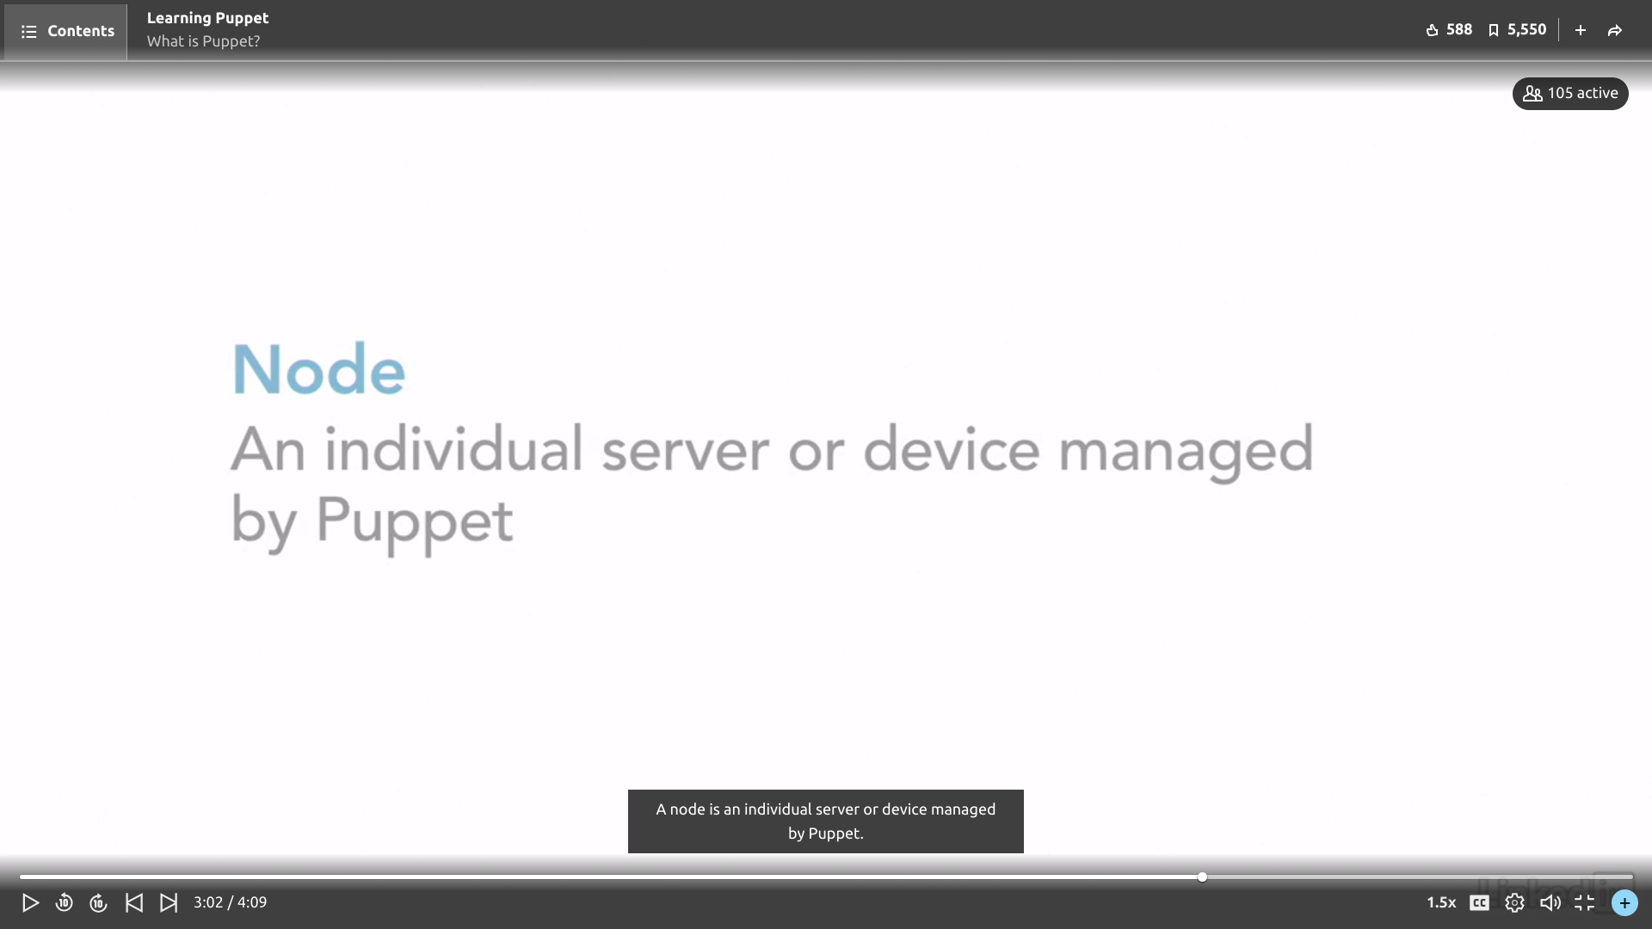

Resources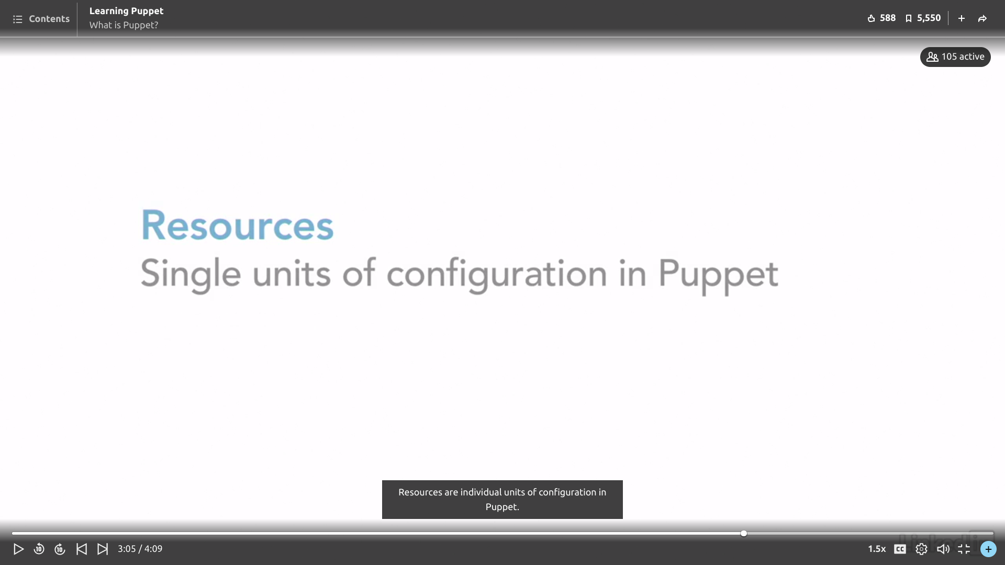

Class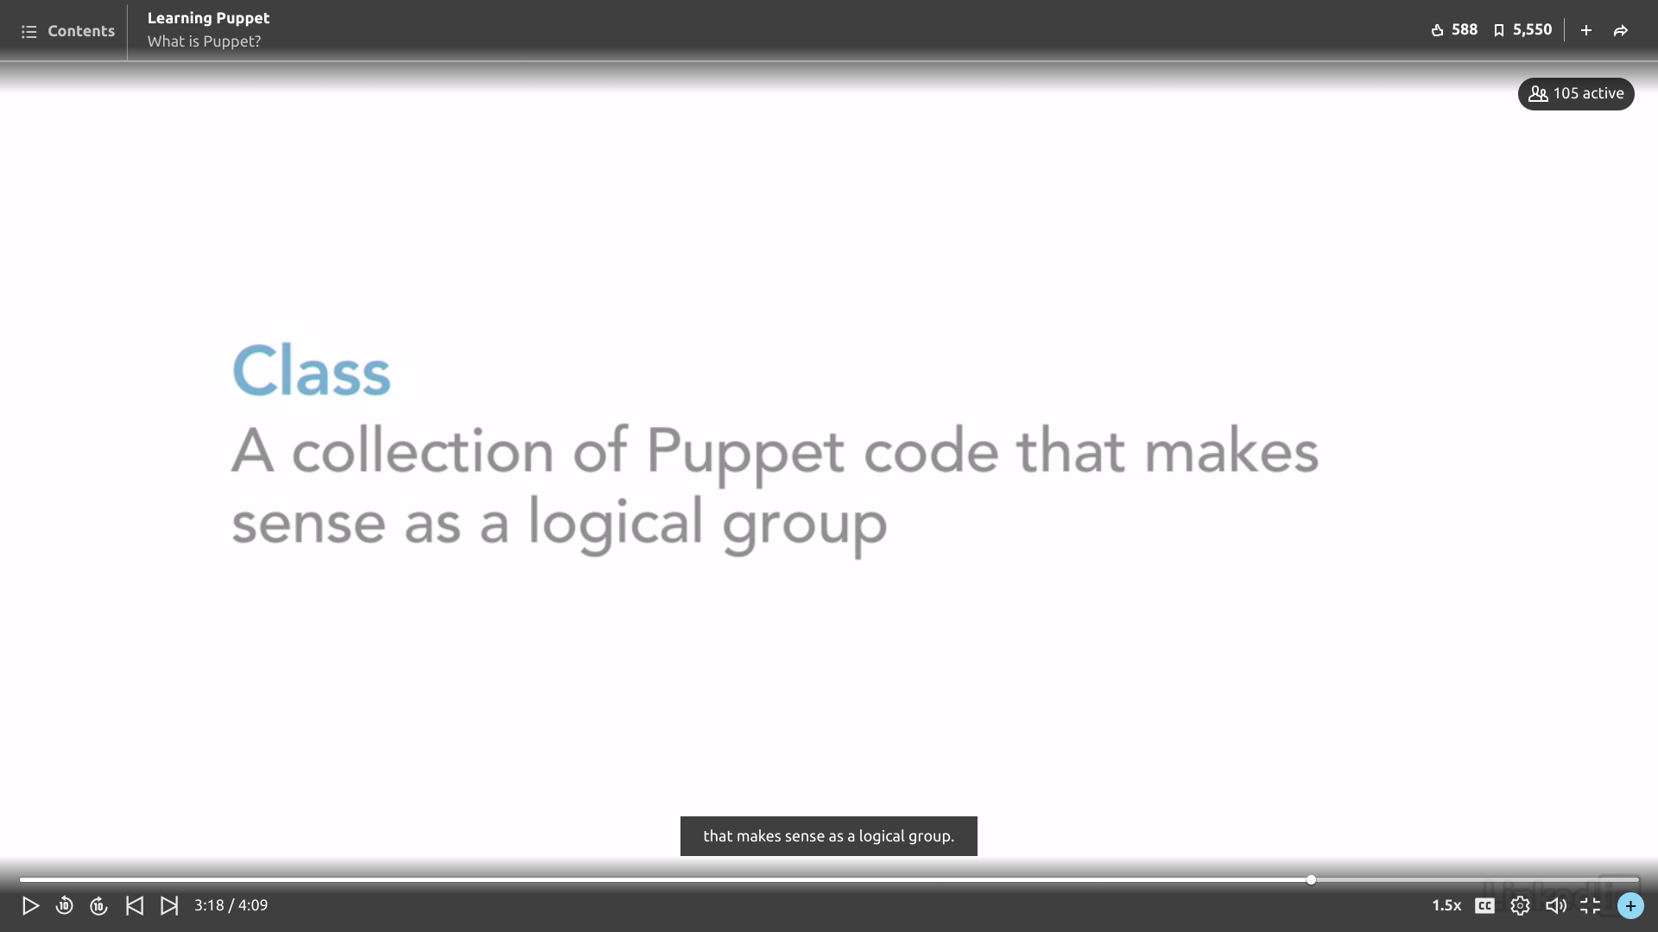

Manifest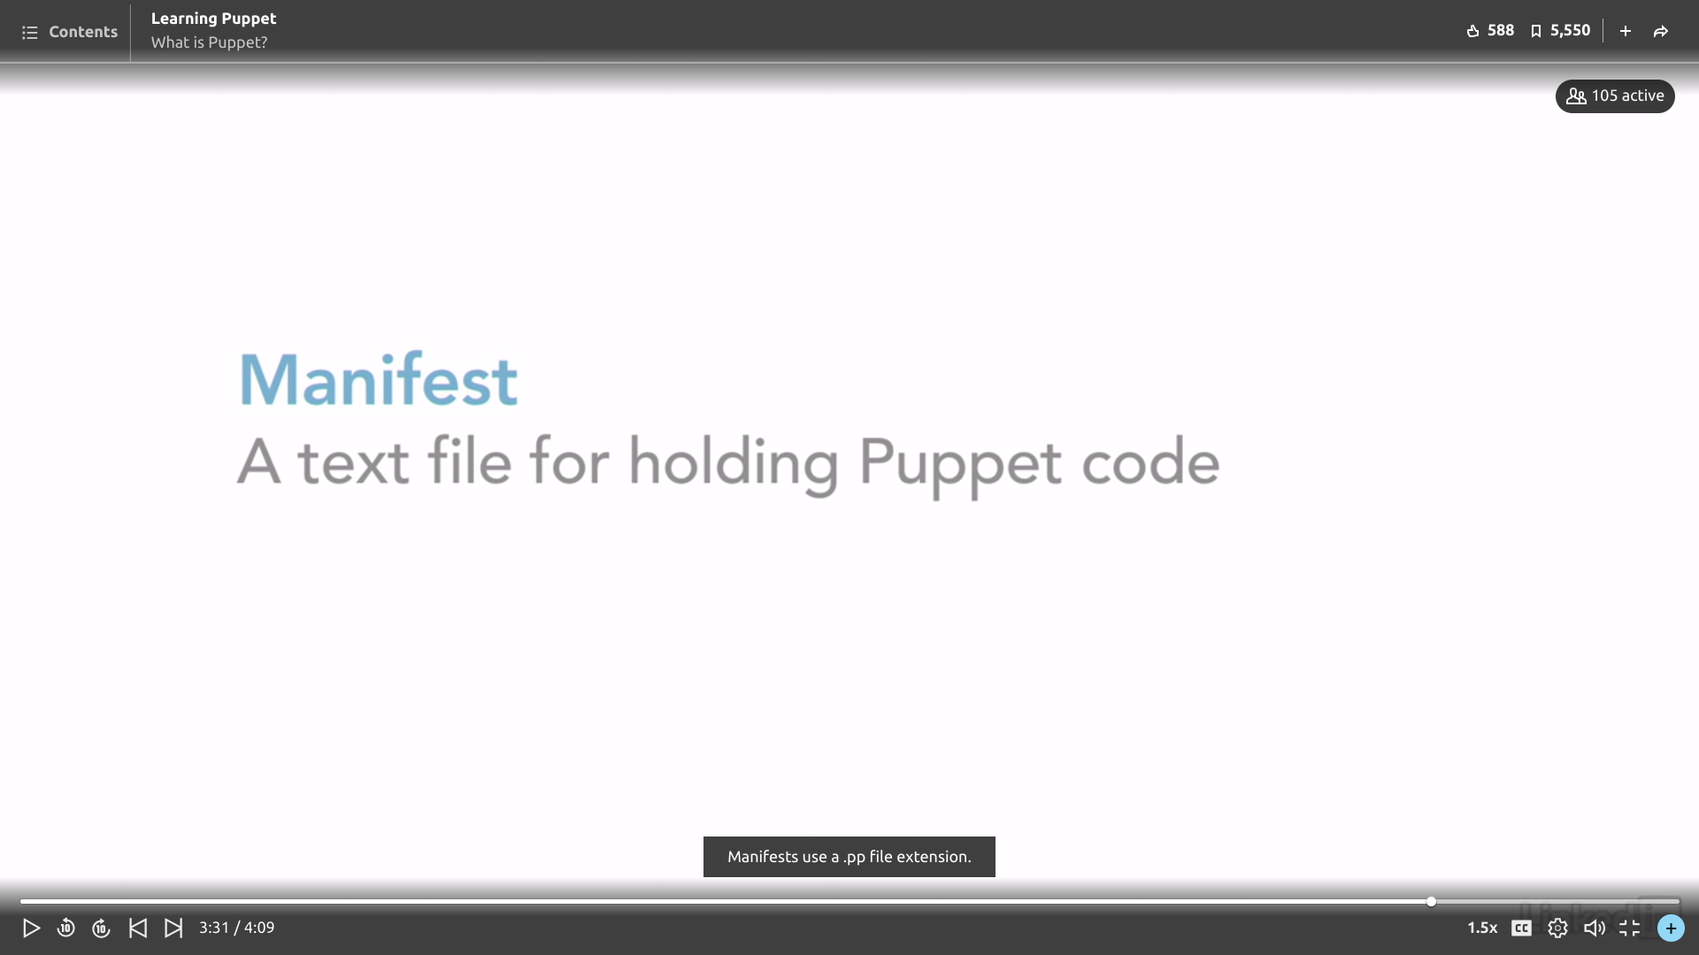

Role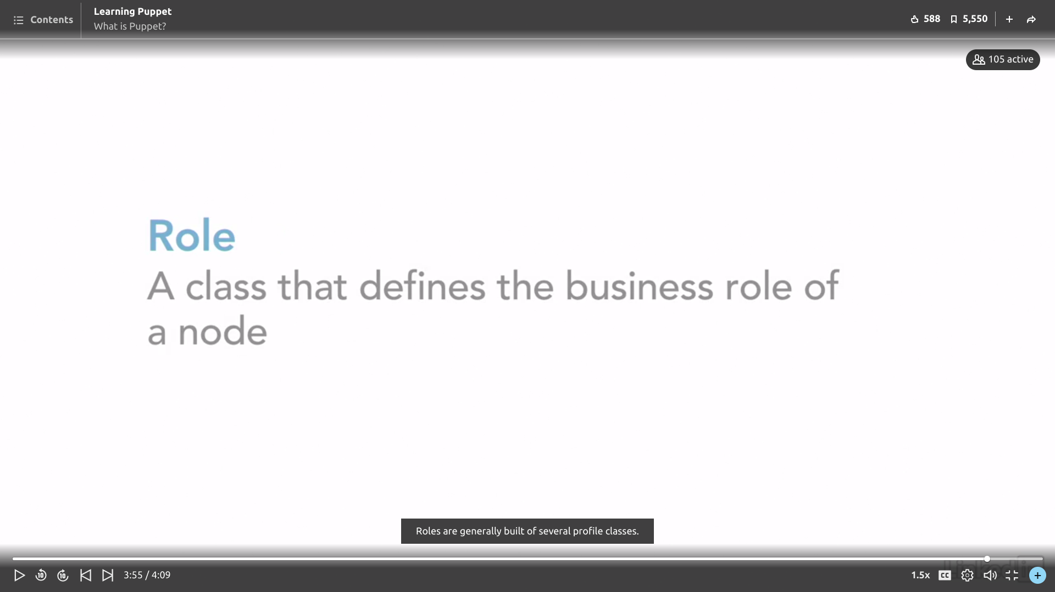

# **What is puppet?**

# It describes System Configuration.

# **Features of Puppet.**

# Puppet Architecture.

It follows a master slave architecture in which master(Administrator) communicate with its clients(nodes) via ssl certificates. Authorization is to be done first and then it can communicate to provide masters data foe any change.

I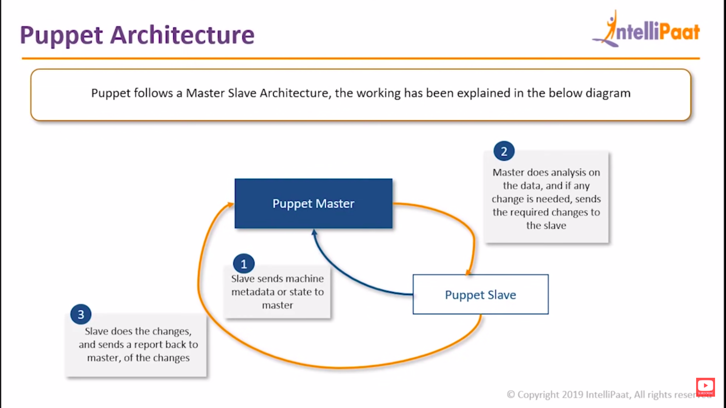

# SSL Connection

## If many servers get down simultaneously it cant be resolved by testing each server at a particular time.So to avoid this problem we use puppet so that all servers are rolled back to their previous working states.Manifests are to be written for the system configuration.So here’s the components of puppet in which manifests+templates+files are together called modules and which require certificate authority .This block is called Puppet Master.

## Puppet sale are the clients or the node which have their agents .Here’s the working of Puppet.

## SSL certificates are are required for the communication.

## We can see the flow of transfer certificate followed by data.

# A report is generated by client that describes the changes made and is sent to master.Requirements to be done to install puppet in clients machine as well as in administrator machine.Installing Puppet

Ifconfig specifies the ip address of machine.

ANd puppet server is the pupper master.

# 

## Classifying hostname and installing puppet master.Puppet Slave is the puppet client installing in clients in clients machine.Showing the connection of the master-slave.Here’s the example if changes made in clients machine that is been configured by master.Installing ApacheMainfests in puppet

## Flow of Manifest.

## Syntax

## ExamplePuppet Forge–**Puppet Forge** is a catalogue of modules created by Puppet

## Puppet DSL–LanguageWhich one is better?

## Differentiation of all System Configuration tools?

## Needed for good sdlc.ANsible VS Puppet

# 